Article Title
Firstname Lastname ^{1,2,}*, Firstname Lastname ³ and Firstname Lastname ⁴
¹Affiliation1.
²Affiliation2.
³Affiliation3.
⁴Affiliation4.
* email: correspondingauthor@email.com
Academic Editors: Firstname Lastname and Firstname Lastname
Abstract
A single paragraph of about 300 words maximum. For research articles, abstracts should give a pertinent overview of the work. We strongly encourage authors to use the following style of structured abstracts, but without headings: (1) Background: Place the question addressed in a broad context and highlight the purpose of the study; (2) Methods: briefly describe the main methods or treatments applied; (3) Results: Summarize the article’s main findings; (4) Conclusions: Indicate the main conclusions or interpretations. The abstract should be an objective reresentation of the article and it must not contain results that are not presented and substantiated in the main text and should not exaggerate the main conclusions.
Keywords: keyword 1; keyword 2; keyword 3 (List three to ten pertinent keywords specific to the article; yet reasonably common within the subject discipline.)
Citation: Lastname F, Lastname F. Article title. Journal of Experimental Pharmacology and Toxicology yyyy;Volume. https://doi.org/xxxxxx/xxx

1. Introduction
The introduction should briefly place the study in a broad context and highlight why it is important. It should define the purpose of the work and its significance. The current state of the research field should be carefully reviewed and key publications cited. Please highlight controversial and diverging hypotheses when necessary. Finally, briefly mention the main aim of the work and highlight the principal conclusions. As far as possible, please keep the introduction comprehensible to scientists outside your particular field of research. References should be numbered in order of appearance and indicated by a numeral or numerals in square brackets—e.g., [1] or [2,3], or [4–6]. See the end of the document for further details on references.

2. Materials and methods
The Materials and Methods should be described with sufficient details to allow others to replicate and build on the published results. Please note that the publication of your manuscript implicates that you must make all materials, data, computer code, and proto-cols associated with the publication available to readers. Please disclose at the submission stage any restrictions on the availability of materials or information. New methods and protocols should be described in detail while well-established methods can be briefly de-scribed and appropriately cited.
Research manuscripts reporting large datasets that are deposited in a publicly available database should specify where the data have been deposited and provide the relevant accession numbers. If the accession numbers have not yet been obtained at the time of submission, please state that they will be provided during review. They must be provided prior to publication.
Interventionary studies involving animals or humans, and other studies that require ethical approval must list the authority that provided approval and the corresponding ethical approval code.

2.1. Subsection

2.1.1. Subsubsection
In this study, 145 elderly patients (51 males and 94 females) with musculoskeletal disorders (e.g., back pain, arthritis, and osteo- arthritis) participated. A convenience sample was used. One hundred and fifty questionnaires were distributed, and 145 patients provided complete data. The mean age was 74.8 ± 9.12 years. The inclusion criteria were (a) diagnosed with muscu- loskeletal disorders, (b) aged from 18 to 60 years and older, and (c) ability to communicate in Greek. The main exclusion criteria (Figure 1).
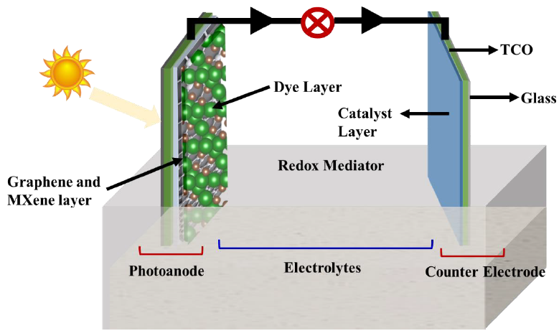
Figure 1. This is the Figure caption example.

3. Results
This section may be divided by subheadings. It should provide a concise and precise description of the experimental results, their interpretation, as well as the experimental conclusions that can be drawn.
This is the quotation example: results present some sociodemographic and clinical characteristics of the sample. Specifically, the mean age of the participants was 74.8 ± 9.12. The mean duration since the diagnosis of musculoskeletal problems was 16.2 ± 11.9 years, while the mean duration of treatment
In Table 1, frequencies of sociodemographic characteristics are presented. Specifically, the majority of the patients were female (64.8%), were married (53.8%), had municipal education (53.8%), were retired (84.1%), had heavy manual work (47.6%), did not have a paid or unpaid assistant (68.3%), had a moderate financial status (44.8%), lived in an urban area (67.6%), and had a public insurance (95.2%).
Bulleted lists look like this:
- First bullet;
- Second bullet;
- Third bullet.
Numbered lists can be added as follows:
- First item;
- Second item;
- Third item.
The text continues here.
In Table 1, frequencies of sociodemographic characteristics are presented. Specifically, the majority of the patients were female (64.8%), were married (53.8%), had municipal education (53.8%), were retired (84.1%), had heavy manual work (47.6%), did not have a paid or unpaid assistant (68.3%), had a moderate financial status (44.8%), lived in an urban area (67.6%), and had a public insurance (95.2%).
Table 1. This is the Table caption example that body is in 1 column.
 | Counts | Percentage of total | Cumulative percentage
Gender
Male | 51 | 35.2 | 35.2
Female | 94 | 64.8 | 100.0
Marital status
Married | 78 | 53.8 | 53.8
Single | 7 | 4.8 | 58.6
Widowed | 47 | 32.4 | 91.0
Divorced | 13 | 9.0 | 100.0
Education
Municipal | 78 | 53.8 | 53.8
Gymnasium | 14 | 9.7 | 63.4
Lyceum | 19 | 13.1 | 76.6
After lyceum | 15 | 10.3 | 86.9
University | 19 | 13.1 | 100.0
Work status
Retired | 122 | 84.1 | 84.1
Employee | 9 | 6.2 | 90.3
Housework | 14 | 9.7 | 100.0
Type of work
Heavy manual | 69 | 47.6 | 47.6
Table may have Table footer.

Acknowledgments
Content here.

Funding
Content here.

Author contributions
Content here.

Conflict of interest
Content here.

Data availability statement
Content here.

Institutional review board statement
Content here.

Informed consent statement
Content here.

Sample availability
Content here.

Additional information
Received: yyyy-mm-dd
Accepted: yyyy-mm-dd
Published: yyyy-mm-dd

Publisher’s note
Journal of Experimental Pharmacology and Toxicology stays neutral with regard to jurisdictional claims in published maps and institutional affiliations. All claims expressed in this article are solely those of the authors and do not necessarily represent those of their affiliated organizations, or those of the publisher, the editors, and the reviewers. Any product that may be evaluated in this article, or claim that may be made by its manufacturer, is not guaranteed or endorsed by the publisher.

Copyright
© yyyy copyright by the authors. This article is an open access article distributed under the terms and conditions of the Creative Commons Attribution (CC BY) license (https://creativecommons.org/licenses/by/4.0/).

References
      - Panahi S, Rathi N, Hurley J, Sundrud J, Lucero M, Kamimura A. Patient adherence to health care provider rec- ommendations and medication among free clinic patients. J Patient Exp. 2022;9:23743735221077523. doi: 10.1177/237 43735221077523
- World Health Organization. Adherence to long-term therapies: evidence for action. In: Sabaté E, editor. World Health Organization; 2003.
- García-Pérez L-E, Alvarez M, Dilla T, Gil-Guillén V, Orozco- Beltrán D. Adherence to therapies in patients with type 2 diabetes. Diabetes Ther. 2013;4:175–94. doi: 10.1007/s13300- 013-0034-y
- Theofilou P. Treatment adherence of diabetes mellitus patients: is it affected by demographic and patient-related factors? A literature review. Acad Med. 2023;1. doi: 10. 20935/AcadMed6108
- Moomba K, Van Wyk B. Social and economic barriers to adherence among patients at Livingstone General Hospital in Zambia. Afr J Prim Health Care Fam Med. 2019;11(1): e1–e6. doi: 10.4102/phcfm.v11i1.1740
- Fernandez-Lazaro CI, García-González JM, Adams DP, Fernandez-Lazaro D, Mielgo-Ayuso J, Caballero-Garcia A, et al. Adherence to treatment and related factors among patients with chronic conditions in primary care: a cross- sectional study. BMC Fam Pract. 2019;20:132. doi: 10.1186/ s12875-019-1019-3

